**Name:** Dev Sapariya

**Roll Number:** 21BCP293

**Division & Group:** Div 5 and G9

**Subject:** Object Oriented Programming With JAVA

**Module 1**

Question 1:

Write a program which will greet you with your name.

**Code**

public class Q1{

    public static void main(String[] args) {

        System.out.println("Have A Nice Day Dev");

    }

}

**Input/Output**

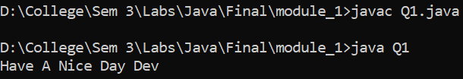

Question 2:

Write a program which will print greeting message for your 5 friends. Friends name should be entered as command line arguments.

**Code**

public class Q2 {

    public static void main(String[] args) {

        System.out.println("Have A Nice Day "+args[0]);

        System.out.println("Have A Nice Day "+args[1]);

        System.out.println("Have A Nice Day "+args[2]);

        System.out.println("Have A Nice Day "+args[3]);

        System.out.println("Have A Nice Day "+args[4]);

    }

}

**Input/Output**

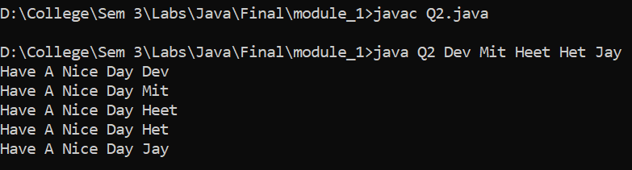

Question 3:

Write a program which will print properties like size, min-value and max-value of each primitive number types in java.(Use appropriate wrapper class).

**Code**

public class Q3{

    public static void main(String[] args) {

        System.out.println("Size of byte: "+Byte.SIZE);

        System.out.println("Max value of byte: "+Byte.MAX_VALUE);

        System.out.println("Min value of byte: "+Byte.MIN_VALUE);

        System.out.println("Size of short: "+Short.SIZE);

        System.out.println("Max value of short: "+Short.MAX_VALUE);

        System.out.println("Min value of short: "+Short.MIN_VALUE);

        System.out.println("Size of int: "+Integer.SIZE);

        System.out.println("Max value of int: "+Integer.MAX_VALUE);

        System.out.println("Min value of int: "+Integer.MIN_VALUE);

        System.out.println("Size of long: "+Long.SIZE);

        System.out.println("Max value of long: "+Long.MAX_VALUE);

        System.out.println("Min value of long: "+Long.MIN_VALUE);

        System.out.println("Size of float: "+Float.SIZE);

        System.out.println("Max value of float: "+Float.MAX_VALUE);

        System.out.println("Min value of float: "+Float.MIN_VALUE);

        System.out.println("Size of double: "+Double.SIZE);

        System.out.println("Max value of double: "+Double.MAX_VALUE);

        System.out.println("Min value of double: "+Double.MIN_VALUE);

        System.out.println("Size of char: "+Character.SIZE);

        System.out.println("Max value of char: "+Character.MAX_VALUE);

        System.out.println("Min value of char: "+Character.MIN_VALUE);

    }

}

**Input/Output**

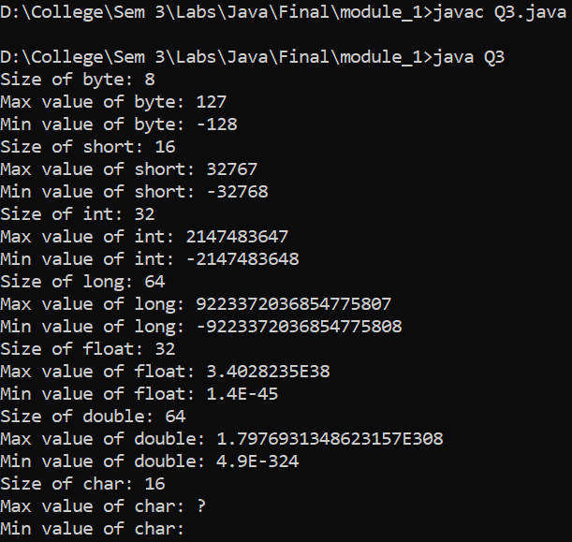

Question 4:

Write a program which will print result of student according to marks.like A grade – marks 90 to 100, B grade – marks 80 to 90, C grade- marks 60 to 80.D grade – marks 45 to 60.E grade – marks 35 to 45. Fail – marks below 35.(Use Else-if ladder).

**Code**

public class Q4 {

    public static void main(String[] args) {

        int marks = 90;

        System.out.println("Marks: "+marks);

        if (marks >= 90 && marks <= 100) {

            System.out.println("A grade");

        } else if (marks >= 80 && marks < 90) {

            System.out.println("B grade");

        } else if (marks >= 60 && marks < 80) {

            System.out.println("C grade");

        } else if (marks >= 45 && marks < 60) {

            System.out.println("D grade");

        } else if (marks >= 35 && marks < 45) {

            System.out.println("E grade");

        } else if (marks < 35) {

            System.out.println("Fail");

        } else {

            System.out.println("Invalid marks");

        }

    }

}

**Input / Output**

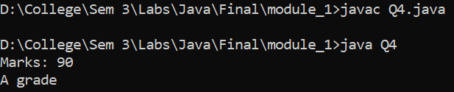

Question 5:

Write a program which demonstrate conditional operator, compound assignment operator, pre-post increment and decrement operator, bitwise operator, logical short circuit operator.

**Code**

public class Q5 {

    public static void main(String[] args) {

        int a = 40;

        int b = 30;

        int c = 20;

        System.out.println("the value of a is " + a);

        System.out.println("the value of b is " + b);

        System.out.println("the value of c is " + c);

        if (a > b && a > c) {

            System.out.println("a is greater");

        }

        if (a > b || a > c) {

            System.out.println("a may be greater than c or b");

        }

        a += b;

        System.out.println("the value of a after a+=b is " + a);

        a++;

        System.out.println("the value of a after a++ is " + a);

        --a;

        System.out.println("the value of a after --a is " + a);

        System.out.println("a & b = " + (a & b));

        System.out.println("a | b = " + (a | b));

        System.out.println("a ^ b = " + (a ^ b));

        System.out.println("~a = " + ~a);

        System.out.println("a << 2 = " + (a << 2));

    }

}

**Input / Output**

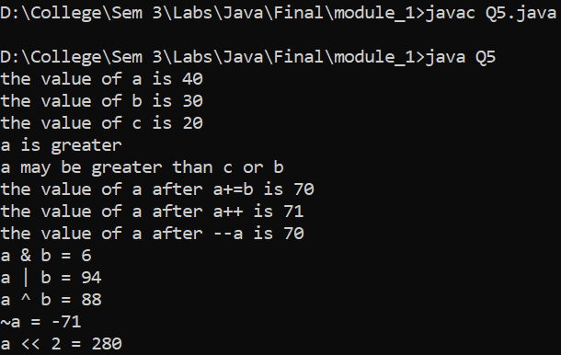

Question 6:

Write a program to print first N prime numbers.

**Code**

import java.util.Scanner;

public class Q6 {

    public static void main(String[] args) {

        Scanner sc = new Scanner(System.in);

        System.out.print("Enter the number: ");

        int n = sc.nextInt();

        int count = 0;

        int i = 2;

        while (count < n) {

            if (isPrime(i)) {

                System.out.println(i);

                count++;

            }

            i++;

        }

    }

    public static boolean isPrime(int n) {

        for (int i = 2; i < n; i++) {

            if (n % i == 0) {

                return false;

            }

        }

        return true;

    }

}

**Input / Output**

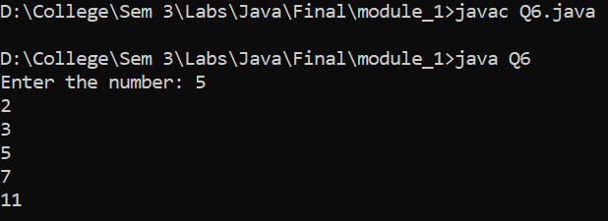

Question 7:

Write a program which will create an array of integers and perform following operation:

1) Sum 2) product 3) Numbers divisible by 15 4) Maximum Value

5) Minimum Value 6) Sort

**Code**

public class Q7 {

    public static void main(String[] args) {

        int[] arr = { 15, 12, 10, 8, 5, 0, 7, 8, 9, 10 };

        int sum = 0;

        int product = 1;

        int count = 0;

        int max = arr[0];

        int min = arr[0];

        for (int i = 0; i < arr.length; i++) {

            sum += arr[i];

            product *= arr[i];

            if (arr[i] % 15 == 0) {

                count++;

            }

            if (arr[i] > max) {

                max = arr[i];

            }

            if (arr[i] < min) {

                min = arr[i];

            }

        }

        System.out.println("Sum: " + sum);

        System.out.println("Product: " + product);

        System.out.println("Numbers divisible by 15: " + count);

        System.out.println("Maximum Value: " + max);

        System.out.println("Minimum Value: " + min);

        for (int i = 0; i < arr.length; i++) {

            for (int j = i + 1; j < arr.length; j++) {

                if (arr[i] > arr[j]) {

                    int temp = arr[i];

                    arr[i] = arr[j];

                    arr[j] = temp;

                }

            }

        }

        System.out.print("Sorted Array: ");

        for (int i = 0; i < arr.length; i++) {

            System.out.print(arr[i] + " ");

        }

    }

}

**Input / Output**

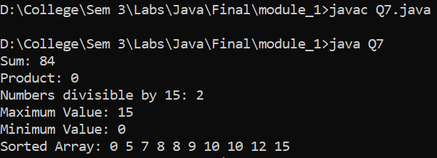

Question 8:

Write an interactive program to print a string entered in a pyramid form. For instance, the string “stream” has to be displayed as follows:

S

S t

S t r

S t r e

S t r e a

S t r e a m

**Code**

import java.util.Scanner;

public class Q8 {

    public static void main(String[] args) {

        System.out.print("Enter the String: ");

        Scanner sc = new Scanner(System.in);

        String a= sc.nextLine();

        for (int i = 0; i < a.length(); i++) {

            for (int j = 0; j < a.length() - i; j++) {

                System.out.print(" ");

            }

            for (int j = 0; j <= i; j++) {

                System.out.print(a.charAt(j) + " ");

            }

            System.out.println();

        }

    }

}

**Input / Output**

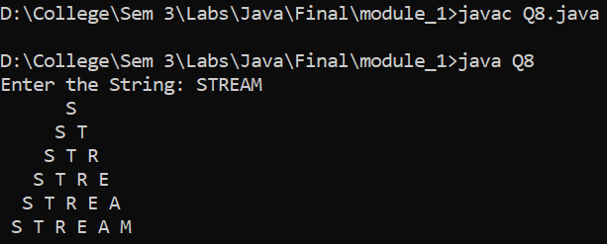

Question 9:

Print following diamond pattern :

*

* *

* * *

* * * *

* * *

* *

*

**Code**

import java.util.Scanner;

public class Q9 {

    public static void main(String[] args) {

        System.out.print("Enter the number of Maximum number of diamond in the row: ");

        Scanner sc = new Scanner(System.in);

        int n = sc.nextInt();

        for (int i = 0; i < n-1; i++) {

            for (int j = 0; j < n - i; j++) {

                System.out.print(" ");

            }

            for (int j = 0; j <= i; j++) {

                System.out.print("* ");

            }

            System.out.println();

        }

        for (int i = 0; i < n; i++) {

            for (int j = 0; j <= i; j++) {

                System.out.print(" ");

            }

            for (int j = 0; j < n - i; j++) {

                System.out.print("* ");

            }

            System.out.println();

        }

    }

}

**Input / Output**

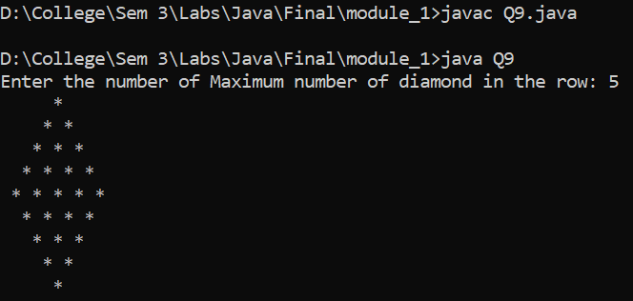

Question 10:

Write a program to accept a line and check how many consonants and vowels are there in line.

**Code**

import java.util.Scanner;

public class Q10 {

    public static void main(String[] args) {

        System.out.print("Enter the String: ");

        Scanner sc = new Scanner(System.in);

        String a = sc.nextLine();

        int v = 0;

        int c = 0;

        for (int i = 0; i < a.length(); i++) {

            if (a.charAt(i) == 'a' || a.charAt(i) == 'e' || a.charAt(i) == 'i' || a.charAt(i) == 'o' || a.charAt(i) == 'u') {

                v++;

            }

            else if(a.charAt(i)==' '){

                continue;

            }

            else {

                c++;

            }

        }

        System.out.println("The number of vowels are: " + v);

        System.out.println("The number of consonants are: " + c);

    }

}

**Input / Output**

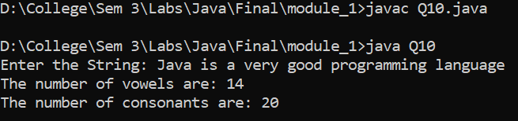

Question 11:

Write a program to count the number of words that start with capital letters.

**Code**

import java.util.Scanner;

public class Q11 {

    public static void main(String[] args) {

        Scanner sc = new Scanner(System.in);

        System.out.print("Enter the String: ");

        String a = sc.nextLine();

        int count = 0;

        for (int i = 0; i < a.length(); i++) {

            if (a.charAt(i) >= 'A' && a.charAt(i) <= 'Z') {

                count++;

            }

        }

        System.out.println("The number of words that start with capital letters are: " + count);

    }

}

**Input / Output**

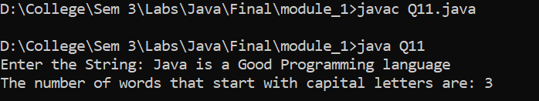

Question 12:

Create a class which ask the user to enter a sentence, and it should display count of each vowel type in the sentence. Display the total count of each vowel and digits for all sentences.

**Code**

import java.util.Scanner;

public class Q12 {

    public static void main(String[] args) {

        Scanner sc = new Scanner(System.in);

        System.out.print("Enter the String: ");

        String string = sc.nextLine();

        int count = 0;

        int a = 0;

        int e = 0;

        int i = 0;

        int o = 0;

        int u = 0;

        int digit = 0;

        for (int j = 0; j < string.length(); j++) {

            if (string.charAt(j) == 'a' || string.charAt(j) == 'A') {

                a++;

            } else if (string.charAt(j) == 'e' || string.charAt(j) == 'E') {

                e++;

            } else if (string.charAt(j) == 'i' || string.charAt(j) == 'I') {

                i++;

            } else if (string.charAt(j) == 'o' || string.charAt(j) == 'O') {

                o++;

            } else if (string.charAt(j) == 'u' || string.charAt(j) == 'U') {

                u++;

            } else if (string.charAt(j) == ' ') {

                continue;

            } else if (string.charAt(j) >= '0' && string.charAt(j) <= '9') {

                digit++;

            } else {

                count++;

            }

        }

        System.out.println("The total number of a in the string is: " + a);

        System.out.println("The total number of e in the string is: " + e);

        System.out.println("The total number of i in the string is: " + i);

        System.out.println("The total number of o in the string is: " + o);

        System.out.println("The total number of u in the string is: " + u);

        System.out.println("The total number of consonants in the string is: " + count);

        System.out.println("The total number of digits in the string is: " + digit);

    }

}

**Input / Output**

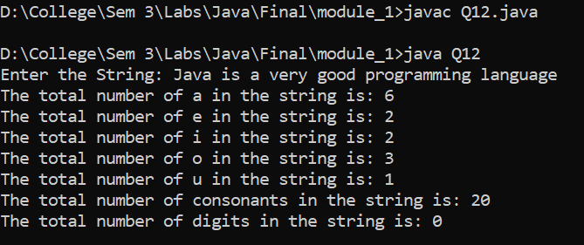

Question 13:

Write a program which will perform following functionality on String:

a) convert to uppercase b) convert to lowercase c) count total words d) substring e) If String ends with Java then concat standardEdition to it f) trim g) string length h) Check weather two strings are equal or not.

**Code**

import java.util.Scanner;

public class Q13 {

    public static void main(String[] args) {

        System.out.print("Enter the String1: ");

        Scanner sc = new Scanner(System.in);

        String string1 = sc.nextLine();

        System.out.print("Enter the String2: ");

        String string2 = sc.nextLine();

        System.out.println("The string1 is: " + string1);

        System.out.println("The string1 in uppercase is: " + string1.toUpperCase());

        System.out.println("The string1 in lowercase is: " + string1.toLowerCase());

        System.out.println("The total number of words in the string1 is: " + string1.split(" ").length);

        System.out.println("The substring of the string1 is: " + string1.substring(0, 5));

        if (string1.endsWith("Java")) {

            System.out.println("The string1 after concatenation is: " + string1.concat("StandardEdition"));

        }

        System.out.println("The string1 after trimming is: " + string1.trim());

        System.out.println("The length of the string1 is: " + string1.length());

        if (string1.equals(string2)) {

            System.out.println("The two strings are equal");

        } else {

            System.out.println("The two strings are not equal");

        }

    }

}

**Input / Output**

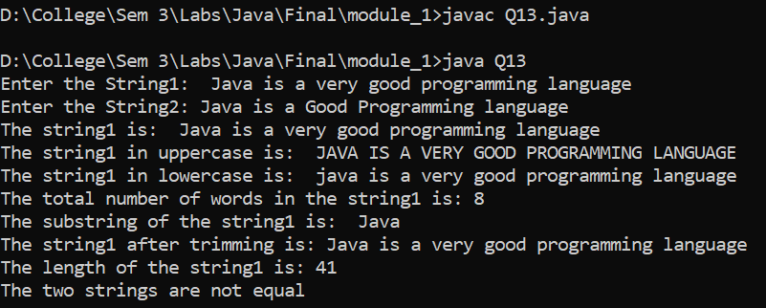

Question 14:

Perform addition and multiplication of two matrix.

**Code**

public class Q14 {

    public static void main(String[] args) {

        int[][] a = { { 1, 2, 3 }, { 4, 5, 6 }, { 7, 8, 9 } };

        int[][] b = { { 1, 2, 3 }, { 4, 5, 6 }, { 7, 8, 9 } };

        int[][] c = new int[3][3];

        int[][] d = new int[3][3];

        System.out.println("Matrix A:");

        for (int i = 0; i < a.length; i++) {

            for (int j = 0; j < a[i].length; j++) {

                System.out.print(a[i][j] + " ");

            }

            System.out.println();

        }

        System.out.println("Matrix B:");

        for (int i = 0; i < b.length; i++) {

            for (int j = 0; j < b[i].length; j++) {

                System.out.print(b[i][j] + " ");

            }

            System.out.println();

        }

        for (int i = 0; i < 3; i++) {

            for (int j = 0; j < 3; j++) {

                c[i][j] = a[i][j] + b[i][j];

                d[i][j] = a[i][j] * b[i][j];

            }

        }

        System.out.println("Addition of two matrix is: ");

        for (int i = 0; i < 3; i++) {

            for (int j = 0; j < 3; j++) {

                System.out.print(c[i][j] + " ");

            }

            System.out.println();

        }

        System.out.println("Multiplication of two matrix is: ");

        for (int i = 0; i < 3; i++) {

            for (int j = 0; j < 3; j++) {

                System.out.print(d[i][j] + " ");

            }

            System.out.println();

        }

    }

}

**Input / Output**

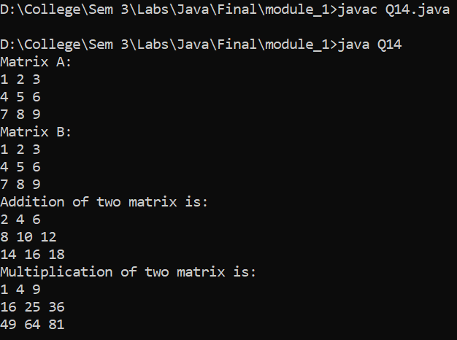

Question 15:

Write a program which will overload method calculateArea which calculates area of different shapes like circle, rectangle and square.

**Code**

public class Q15 {

    static double calculateArea (int r){

        return 3.14*r*r;

    }

    static int calculateArea (int l, int b){

        return l*b;

    }

    public static void main(String[] args) {

        System.out.println("Area of Circle: " + calculateArea(5));

        System.out.println("Area of Rectangle: " + calculateArea(5, 10));

        System.out.println("Area of Square: " + calculateArea(5, 5));

    }

}

**Input / Output**

